JECRC
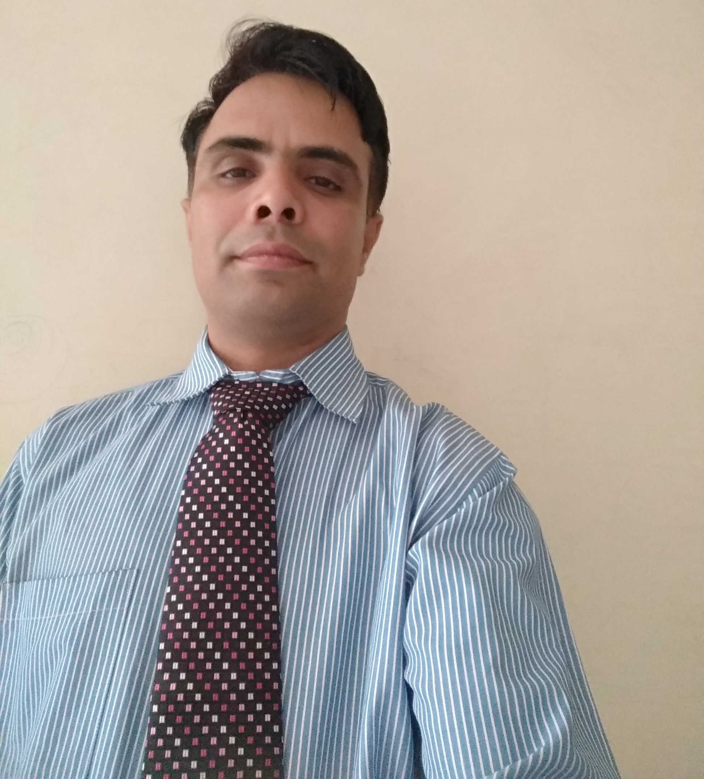
JAIPUR

INDIVIDUAL FACULTY DATA SHEET
Name of the faculty member | : | RAMSINGH
Present Designation | : | ASSISTANT PROFESSOR
Email Id: ramsingh.ee@jecrc.ac.in

Contact Details: 9887712330/8505035536

I. Particulars of Educational Qualification: (only completed)

Category | Name of the Degree | Specialization | Year of Passing | Name of the College | Name of the University
UG | B.E | ELECTRICAL ENGINEERING | 2004 | JECRC JAIPUR | UNIVERSITY OF RAJASTHAN , JAIPUR
PG | M.E* | ELECTRICAL ENGINEERING | Pursuing  (2016-19) | NITTTR CHANDIGARH | PANJAB UNIVERSITY
Ph.D. | - | - | - | - | -

II. Academic Experience : 11+ year

III. Industrial Experience : 3 year

IV. Title of Ph.D. Thesis :

V. Awards/Achievements :

VI. Research/Specialization :

VII. Course Taught : Electrical Machine, Electrical Circuit, Power Electronics
Power System, Instrumentation

VIII. Refereed International Journal Publication : ISBN Number - 2194-5357 (IJST). ISSN: 1381-2416 (print version), version), Journal no. 10772 ,ISI Proceedings, EI-Compendex, DBLP, SCOPUS, Google Scholar and Springer link, ISSN: 1572-8110, 27-28 Feb, 2018 ,

IX. International Conference Proceeding: ICRITETR-2017 (ISSN No. 978-93-5291-761-7),ICICT-18

X. Books Written : Electrical Circuit Analysis-I, Electrical Circuit Analysis-II Ramesh
Book Depot. Jaipur

XI. M.Tech Thesis Guide :

XII. PHD Thesis Guide :

XIII. Professional Body Membership :

